**Purpose:**

This document shows how to retrieve data from SQL server into Power BI

**Scope:**

This document applies to all data analysist and epidemiologist that will be receiving data from sql server and doing data visuals in Power BI .

**Materials:**

|  |  |
| --- | --- |
| File Name | Location |
| Azure server name: | dsda-ndsp-s-sqlserver.database.windows.net |
| Azure database name: | ncird_id_gib |

**Prerequisites**:

* Must have Power BI Desktop
* Access to Global Influenza Azure server and database

**Process:**

1. Open Power BI Desktop
2. Click Get Data.

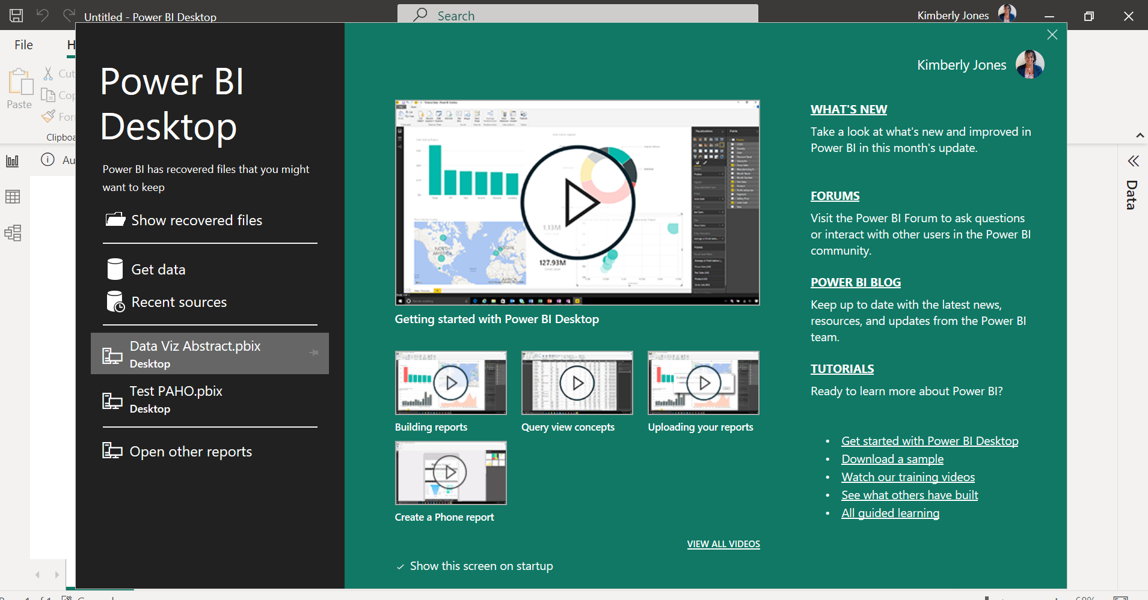

1. Search Azure SQL database >Connect.

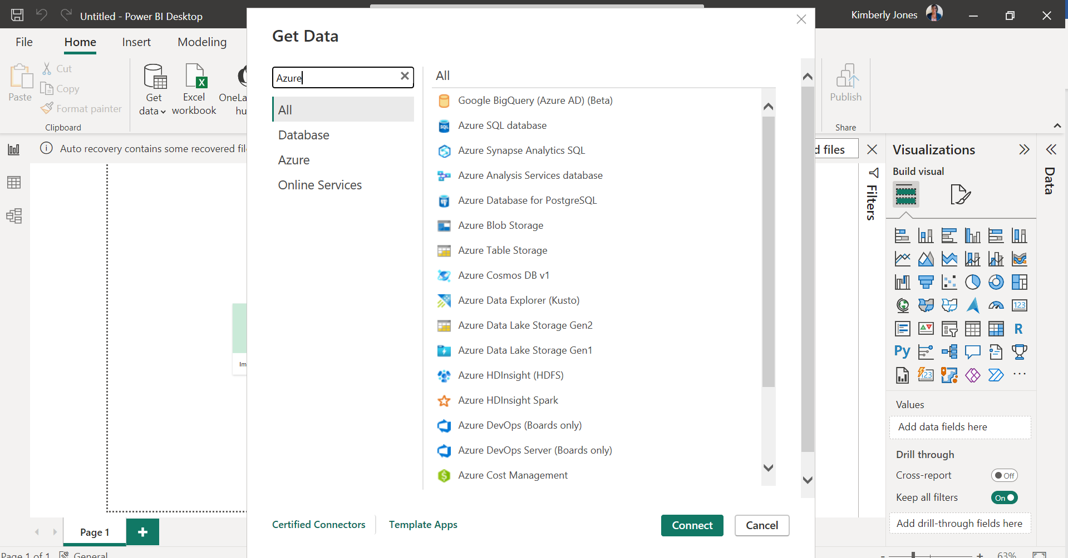

1. Add Database and Server
   1. Database: dsda-ndsp-s-sqlserver.database.windows.net
   2. Server: ncird_id_gib
2. Select Direct Query >OK

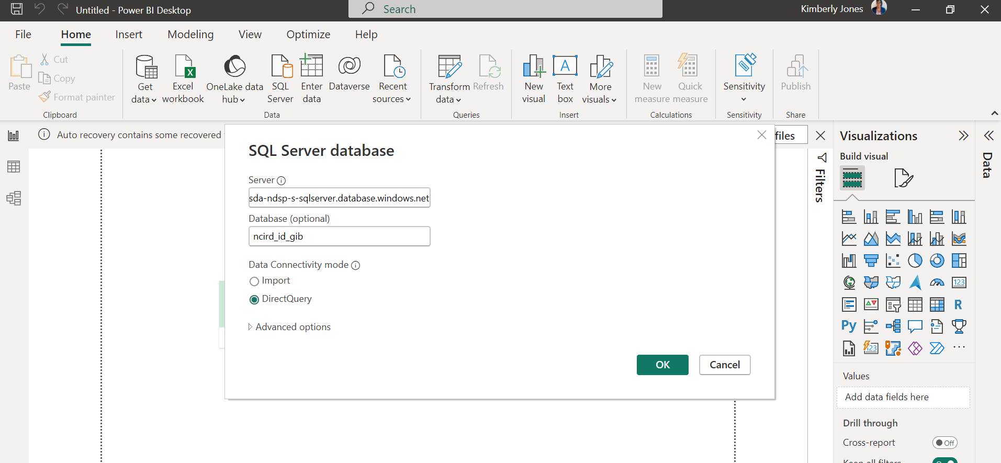

1. Navigator allows you select one or more tables by placing a check mark next to table.
   1. Load- tables are fine and no need to clean.
   2. Transform Data- clean the data within the tables before loading.

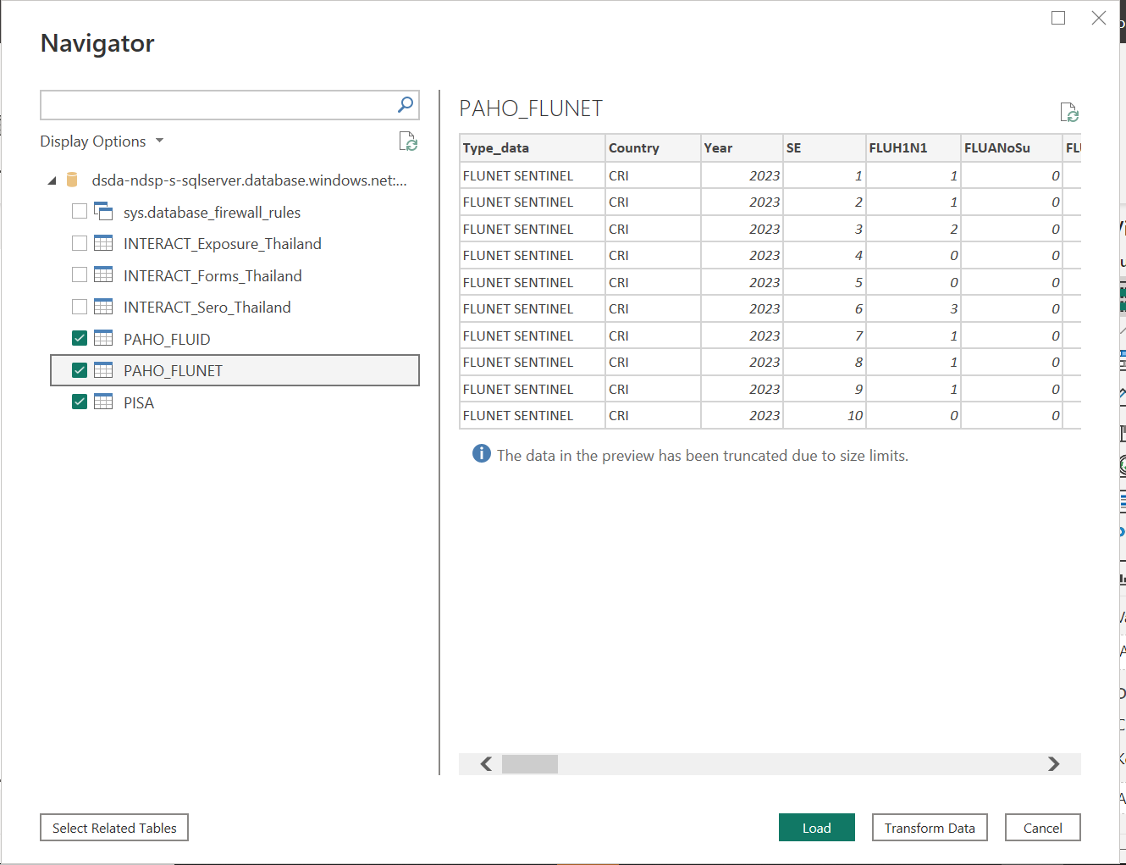

1. Close and Apply
   1. Queries- shows the tables loaded.
   2. Applied Steps- shows data that was transformed or changed.

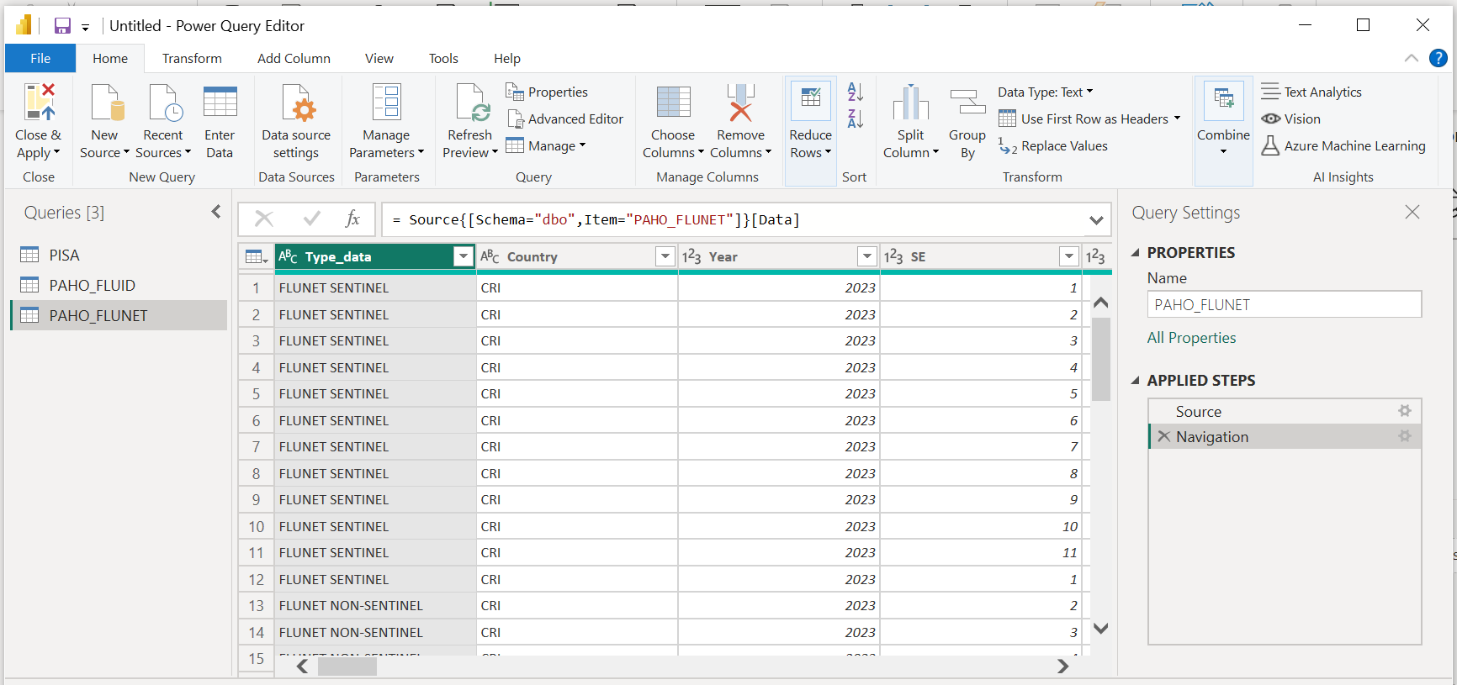

1. Click on the Report icon to the left of the screen.
   1. Data will show on the right side of the screen to begin using for your models.

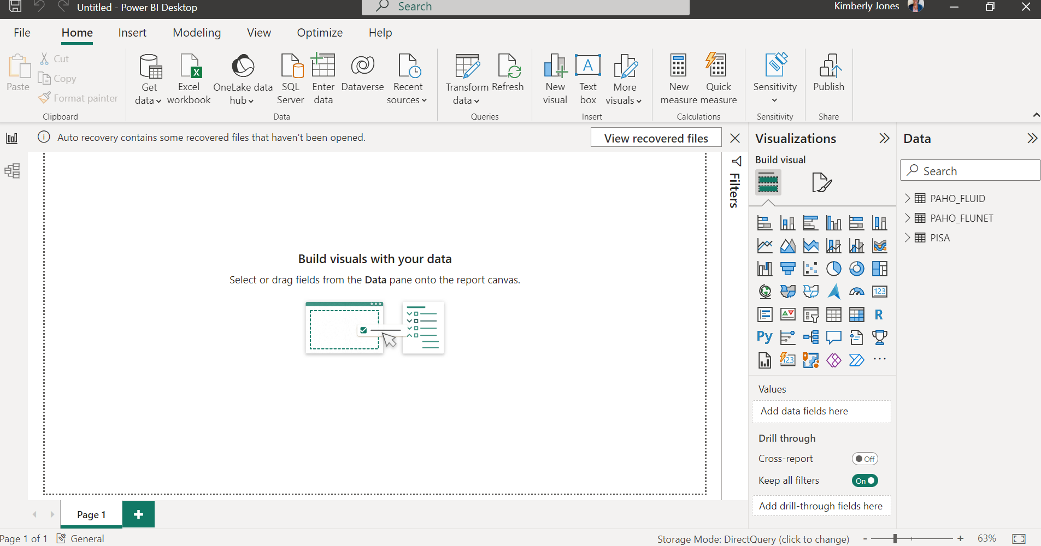

1. On the “Visualization” pane you can select the data visual you want to explore and start creating your data visuals
2. Explore and create your data visuals.

